**Project-Advisor**

**Note:** We have an environment file in the angular project where we need to change the API url of the back-end project.

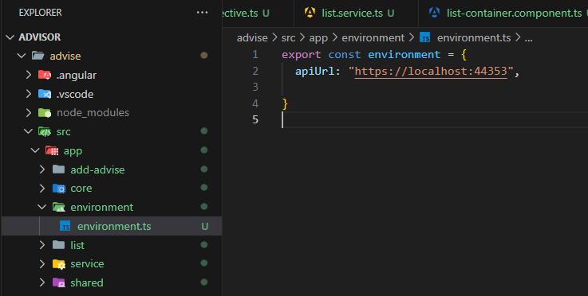

**1 : Fronted of Advisor using Angular :-**

* **List of Advisor :-**

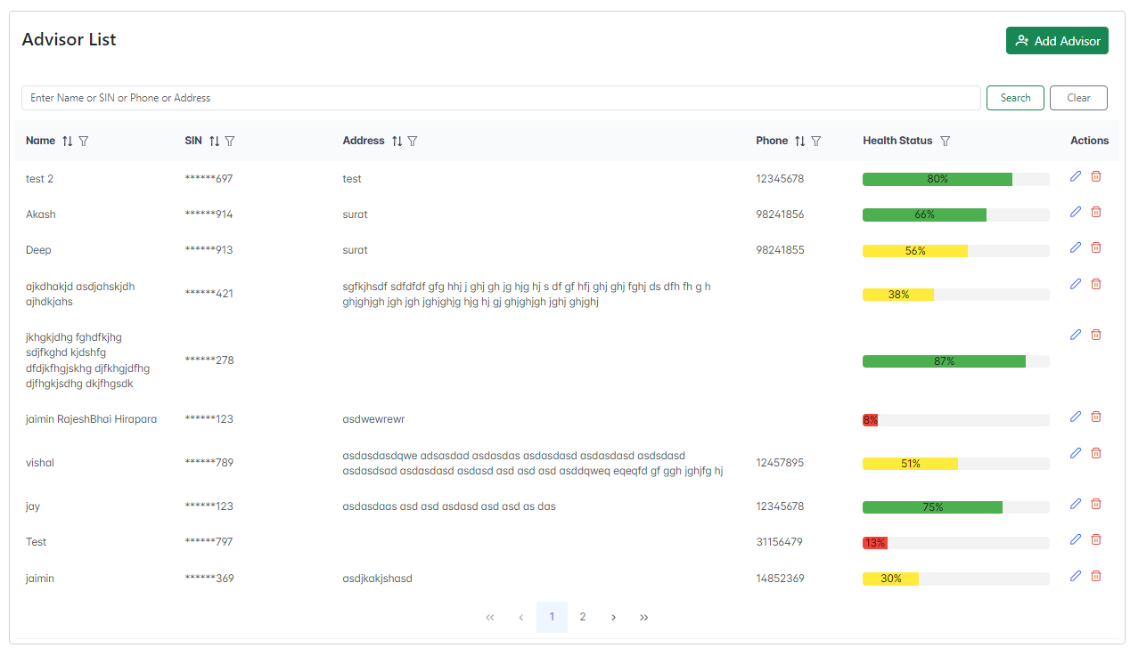

* **Thay show details of Advisor with the data of Name, SIN number,Address,Phone No. and Health Status.**
* **We can edit and delete the exist data that we can add the edit and delete filed**
* **We can add pagination and search fields.**
* **If we add the user for the add field.**
* **Pagination :-**

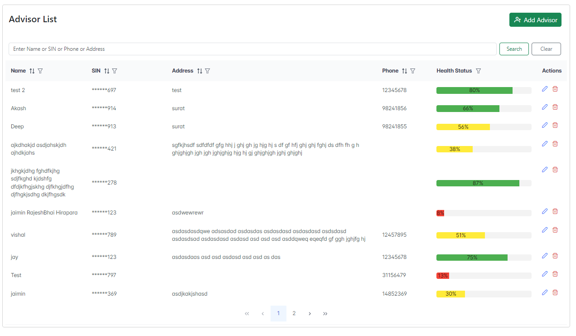

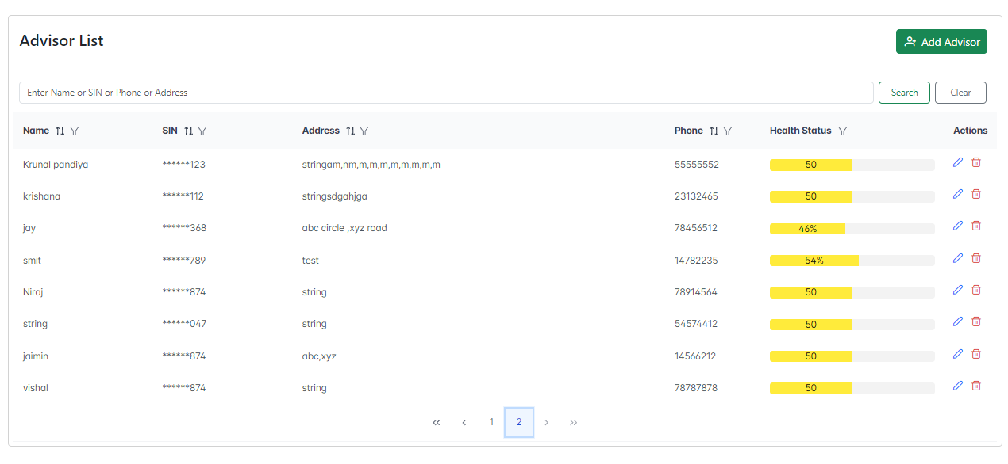

* **In this list view we can add pagination with server side data render.**
* **In this view we can show more data of advisors with pagination.**
* **Add Advisor :-**



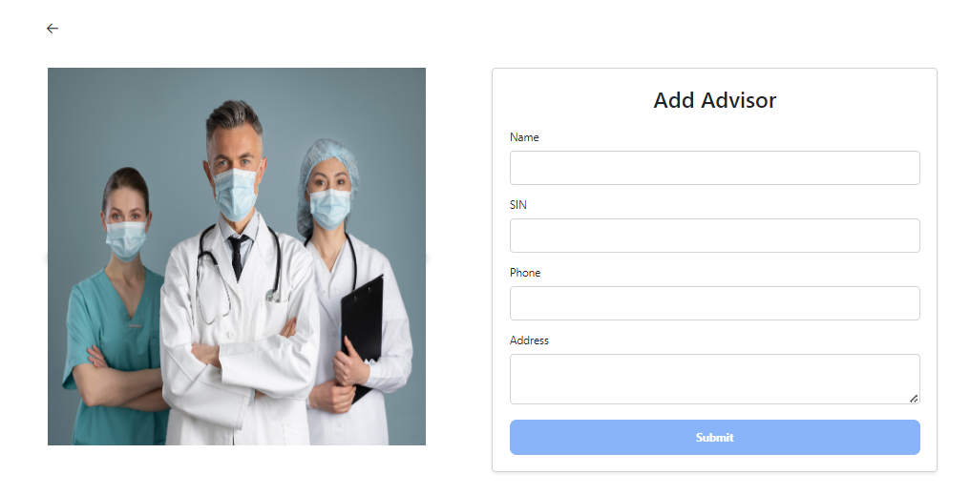

* **This is to add a new Advisor in Advisor List view.**
* **In this form we get the data about the advisor of Name, SIN number, Phone Number and Address.**
* **Also we add the reactive validation**
* **Form Validation**

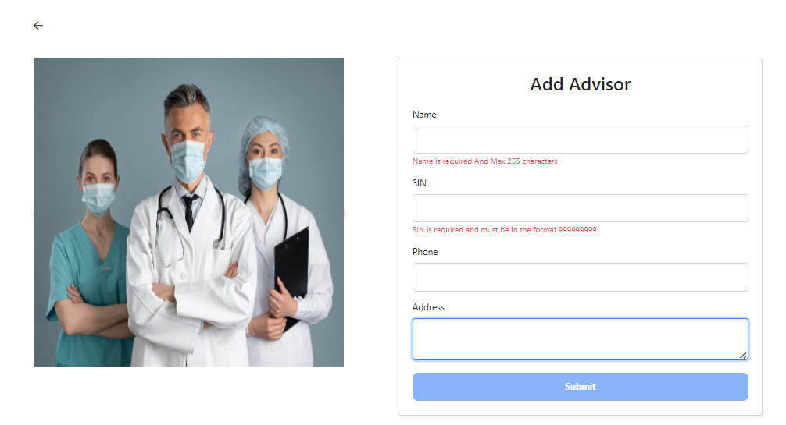

* **If we not add the field submit button will be disable and show the error message in required field**
* **In this form Name and SIN is required field and Phone address is optional field .**
* **Name is max length is 255 characters.**
* **SIN number only 9 Digit number and not least 9.**
* **Phone number only 8 digit number and not least 8.**
* **Address is max length of 255 characters.**

**Test Case: 1**

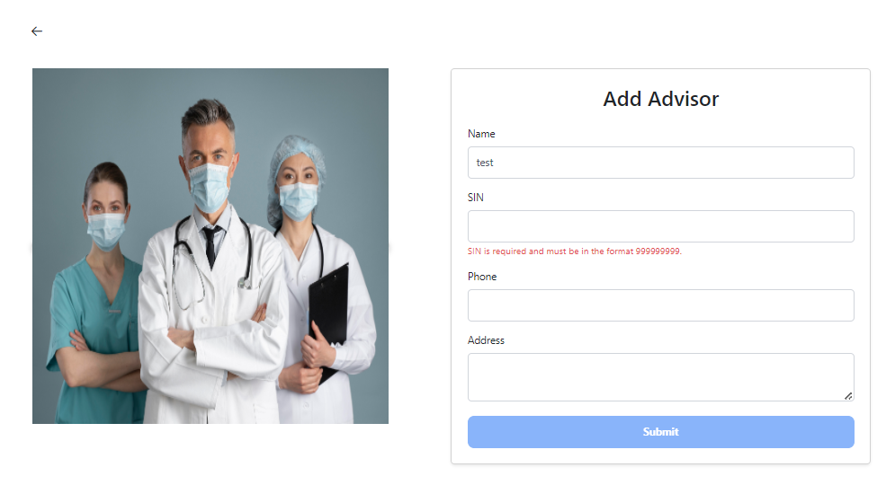

* **If I put only one field they also not accept submit because Sin is required.**

**Test Case 2: (before)**

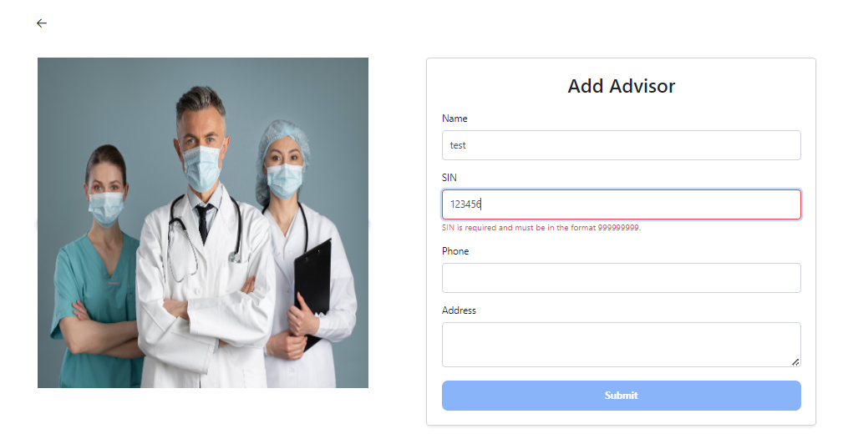

* **If I do not enter exactly a 9 digit SIN number that also shows an error message.**

**Test Case: 2(after)**

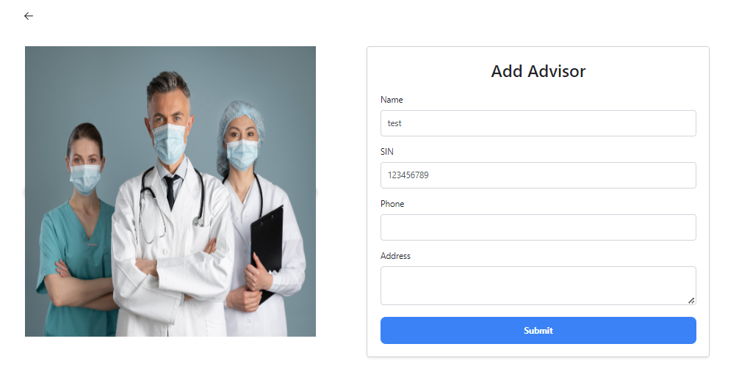

* **They allow it if I enter the 9 digit and they do not allow it if I enter above 9 digit and not the alphabet.**

**Test Case 3:**

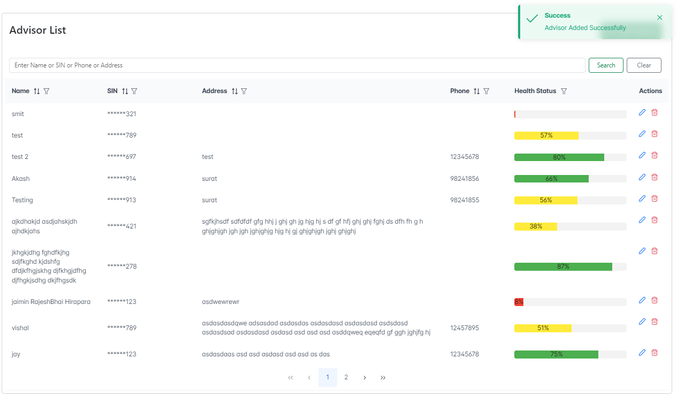

* **If I am not entering phone no. and address also thay submit because they have an optional field.**
* **Add show toaster message and successfully add data.**

**Test Case 4 : (before)**

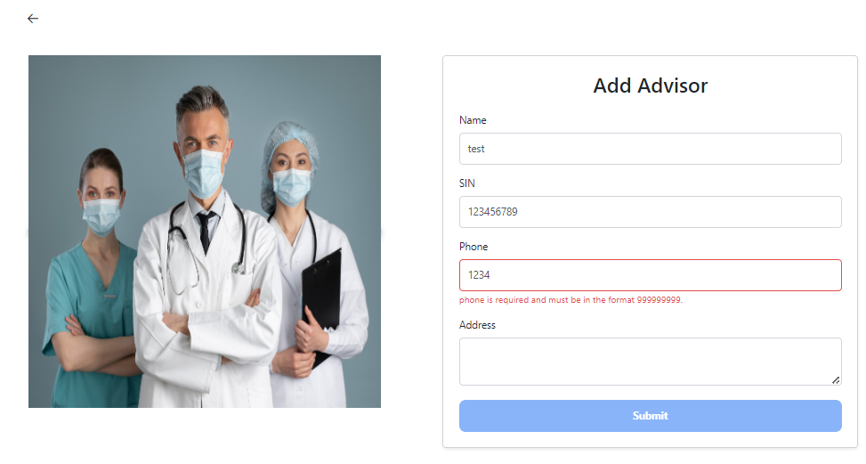

* **If I enter the phone number they also validate if that is exactly 8 numbers than that else they are not allowed to submit.**

**Test Case 4 : (After)**

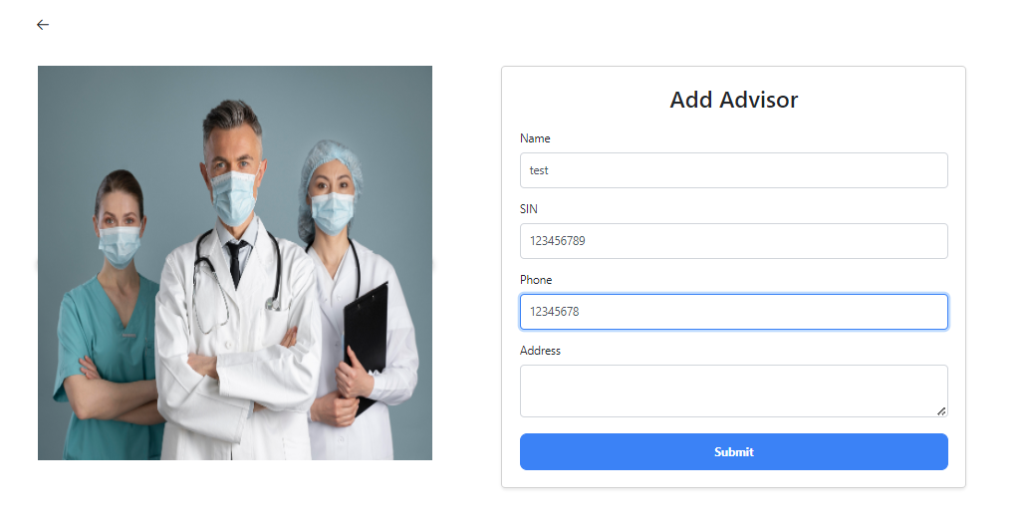

* **If I enter, submit 8 digits that allow me to submit.**
* **Edit Advisor**

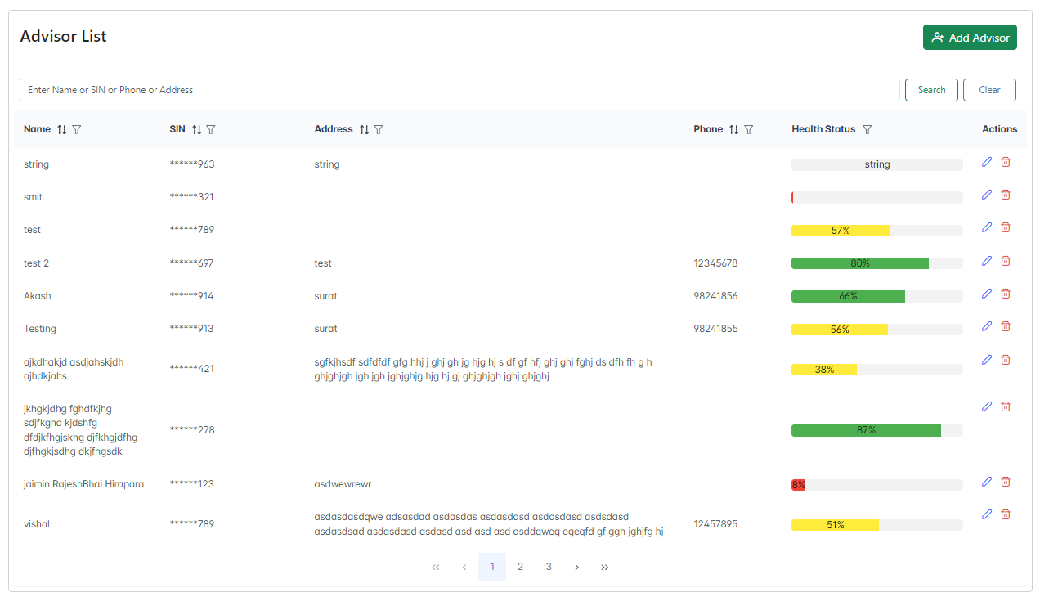

* **In this list view highlighted part I am editing for a test case.**
* **When we click the edit button we redirect to the edit page with existing data.**

**Test Case 1:**

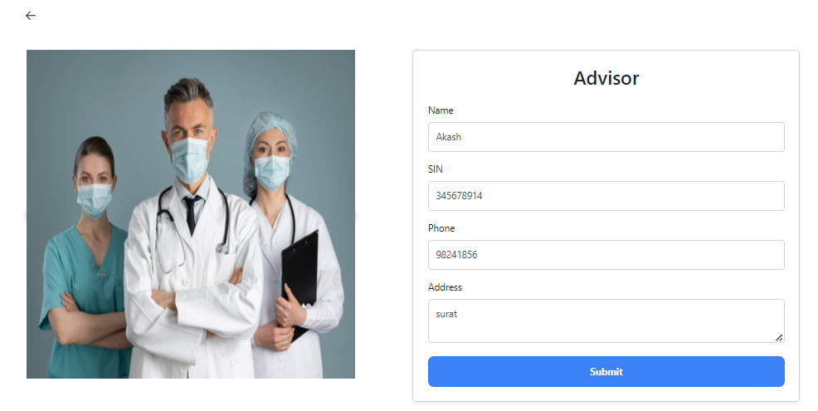

* **When we redirect to an edit form with existing data and we can edit the data.**

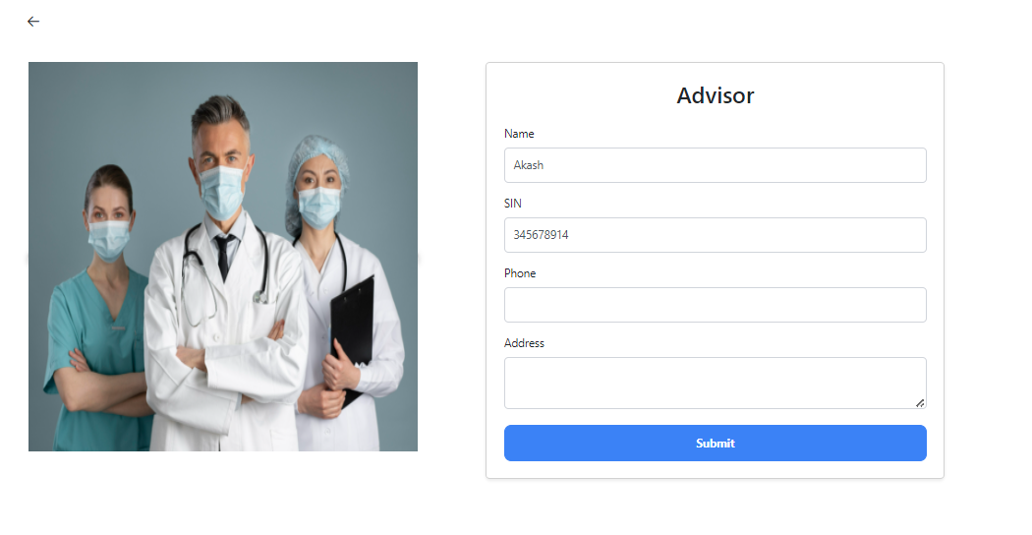

* **We clear the phone and address field and update the advisor .**

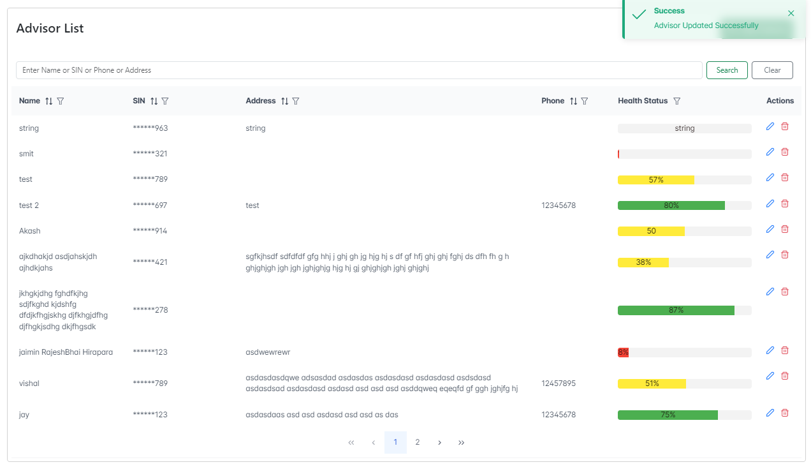

* **We can see the data is without phone and address in akash name.**
* **We can see the toaster on the right corner top advisor updated message.**

**Test Case 2:**

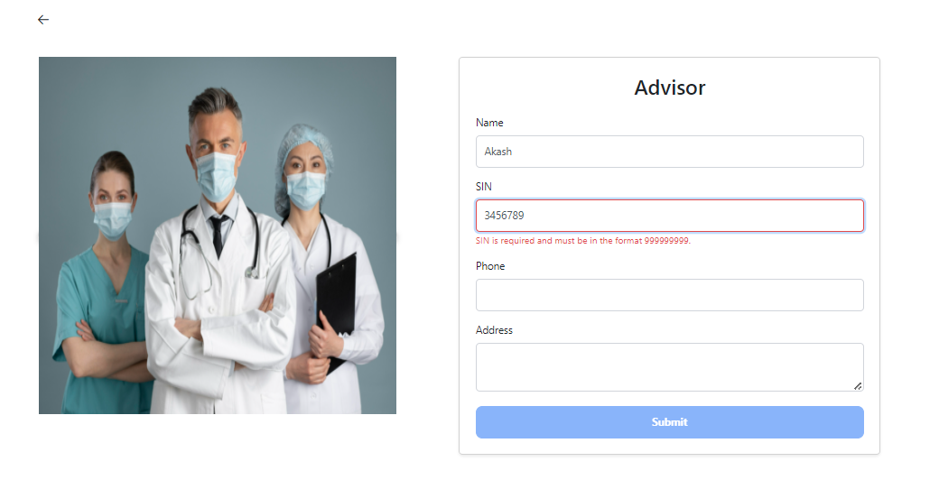

* **If I do not enter exactly a 9 digit SIN number that also shows an error message and submit button is disabled.**
* **Thay check validation for required fields.**

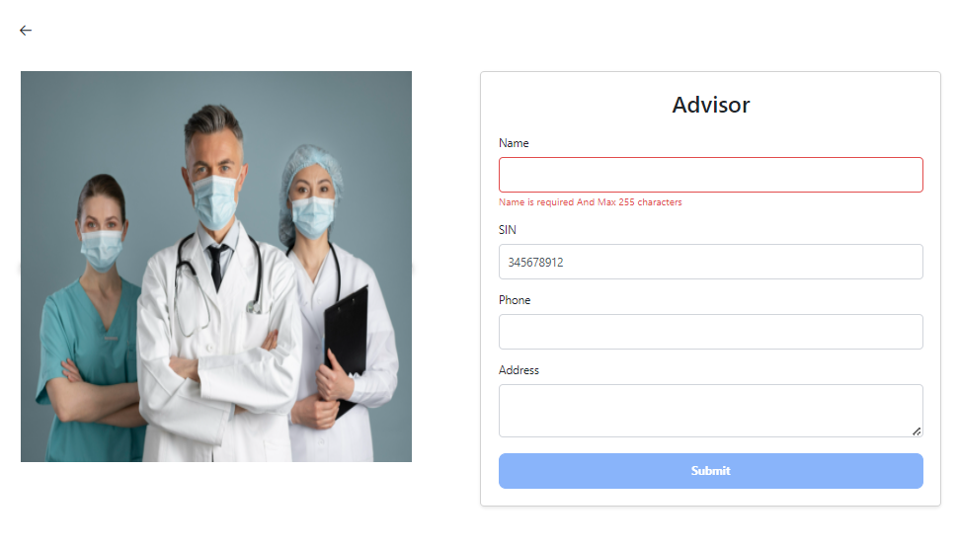

* **If I do not edit the name field that can show error message with disabled button.**

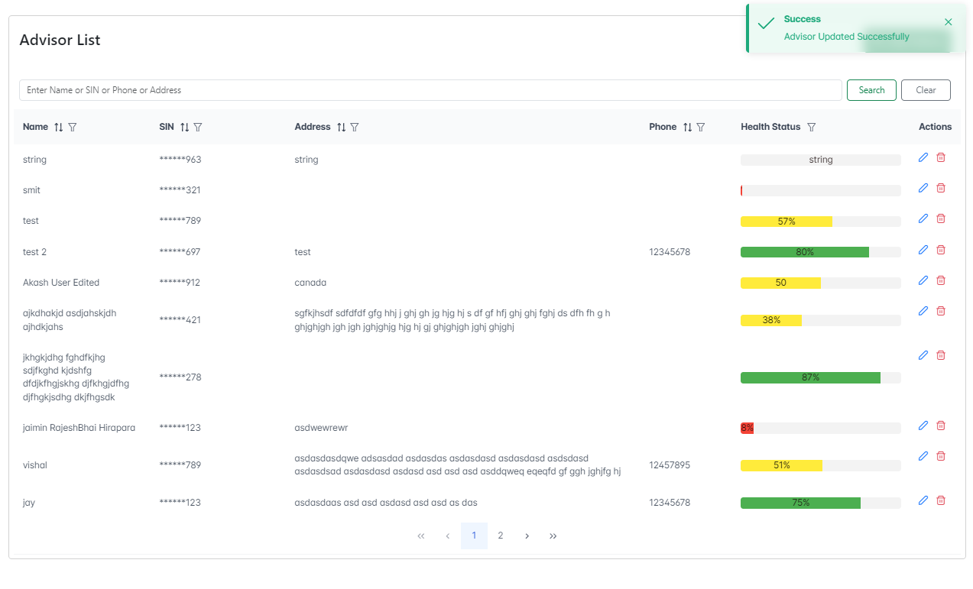

* **Thay edited successfully and showed in listview with highlighted parts.**
* **Delete Advisor**
* **When we click the delete button we can delete the data with confirmation dialog.**

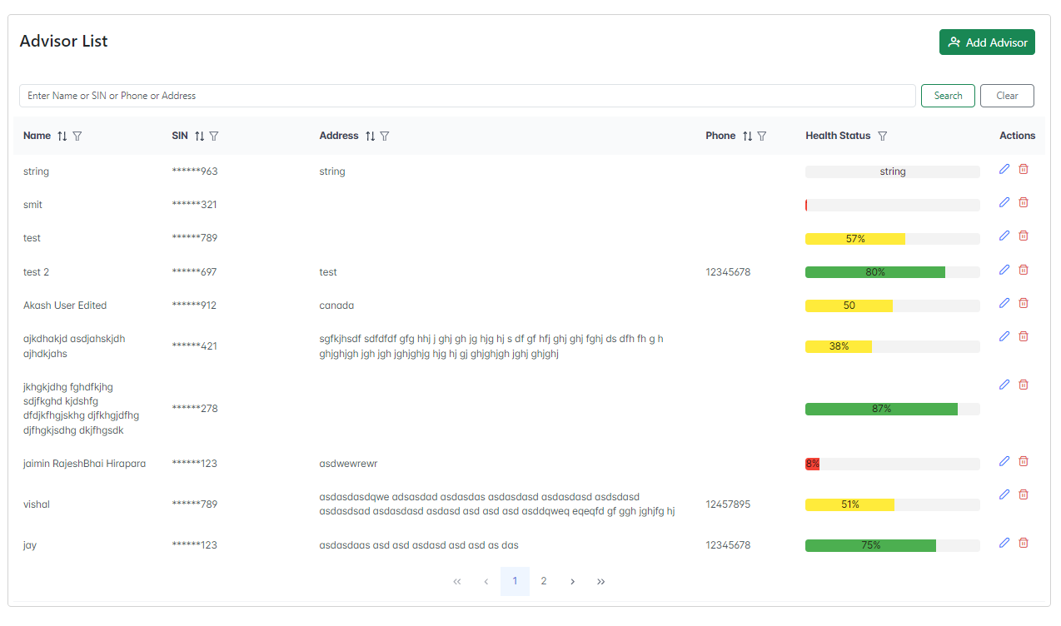

* **We show the list view with the highlighted part we are delete the highlighted part in the list view.**

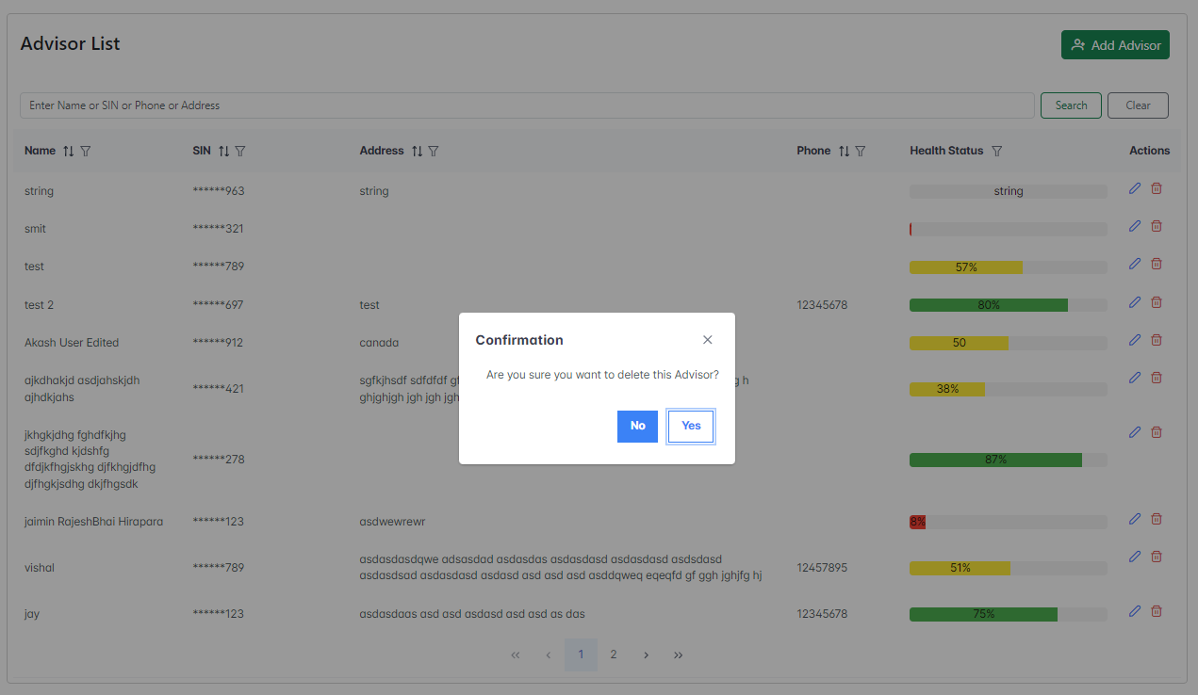

* **When we click on the delete icon we see the confirmation dialog .**
* **If I cancel the confirmation that does not delete the data.**
* **If I can confirm the dialog they can delete the data.**

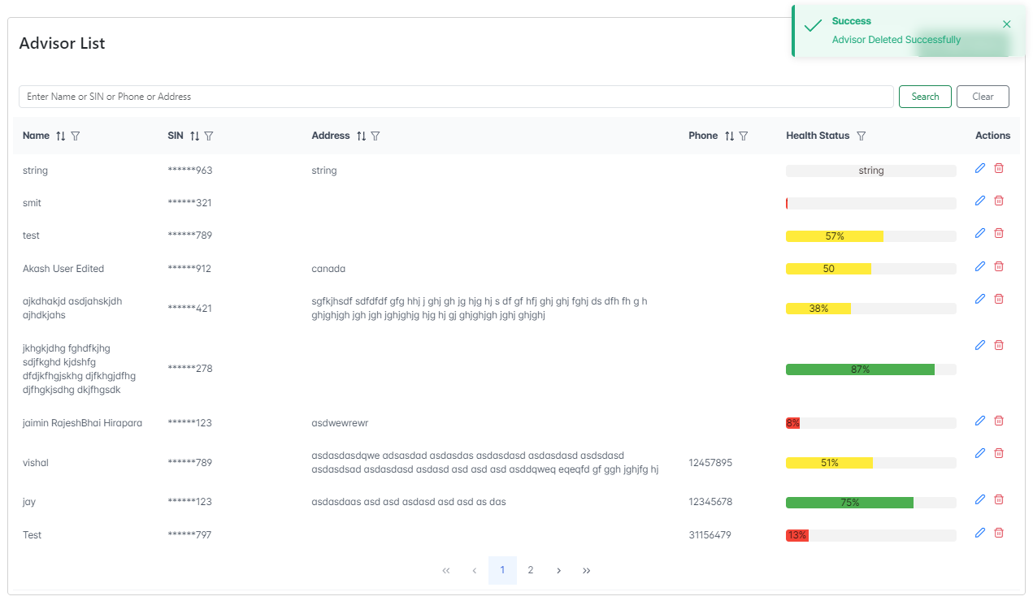 

**🡪 we can see the data was deleted and show the success message in top right corner.**

* **Search and Filters:**

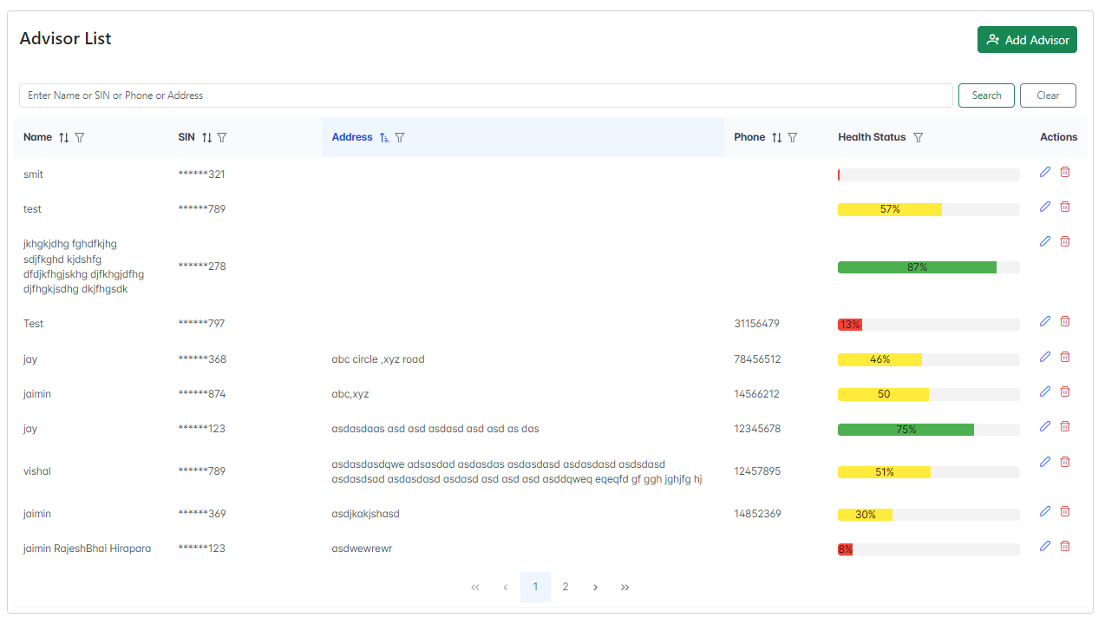

* **We can show the top center search field with the search and clear button.**
* **We are searching for any with the Name, SIN, Phone and address filed .**

1. **Search with name:**

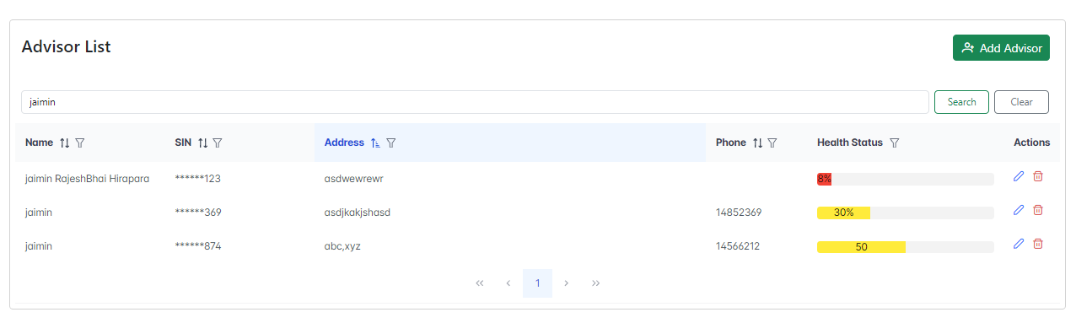

1. **Search with SIN:**

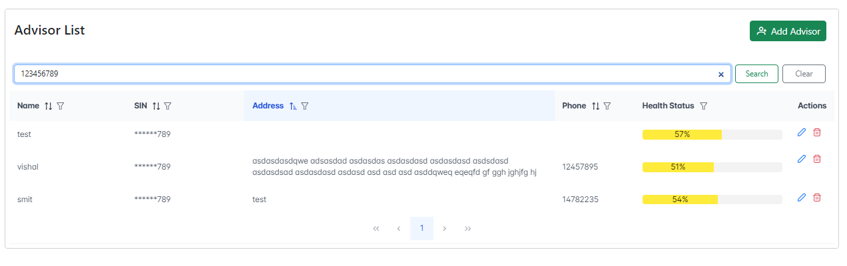

1. **Search with Address:**

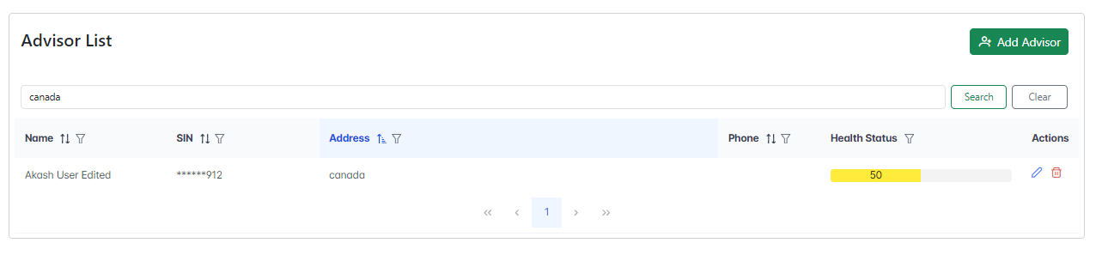

1. **Search with phone:**

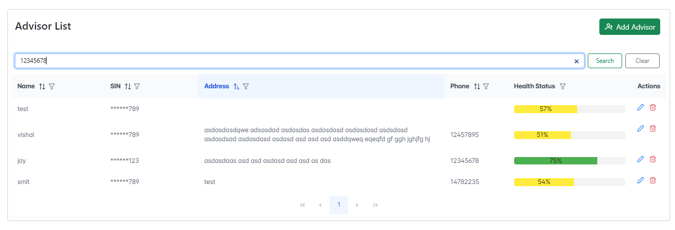

**SortIng:**

* **We can sort according to descending and ascending.**
* 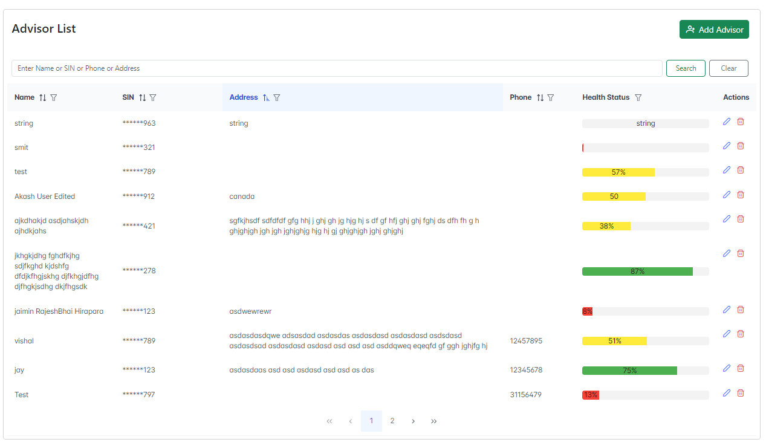
* **We can filter the data as server side and we can sort in Name, SIN, Address and phone.**

1. **Sort with Name (Asc and Desc):**

🡪 **Sorting Name Ascending**

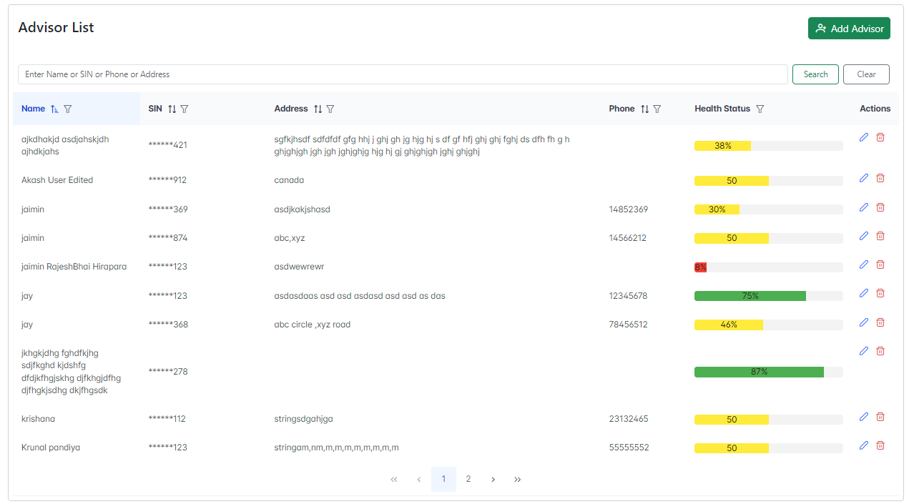

* **Sorting Name descending**

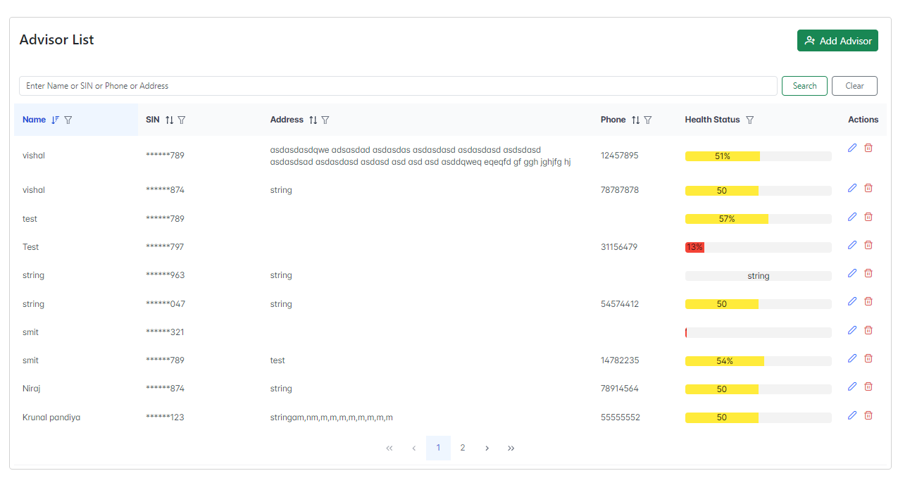

1. **Sort with SIN (Asc and Desc):**

* **Sorting In Ascending**

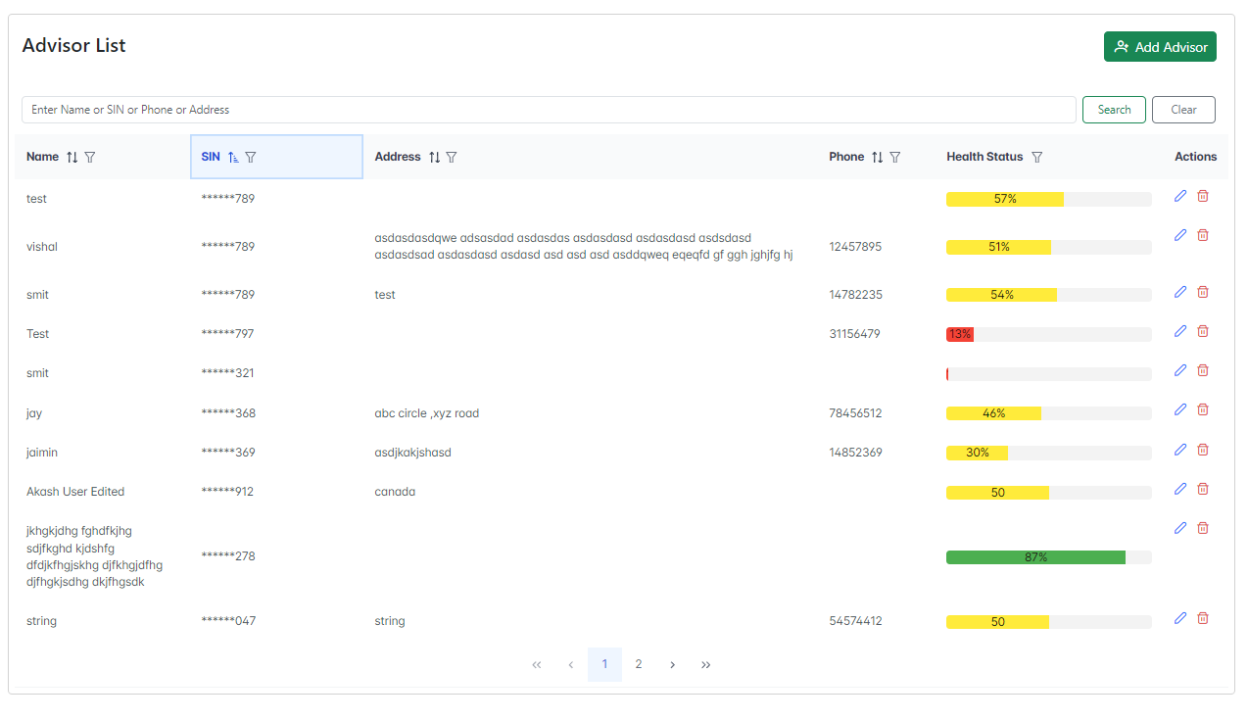

* **Sorting In descending**

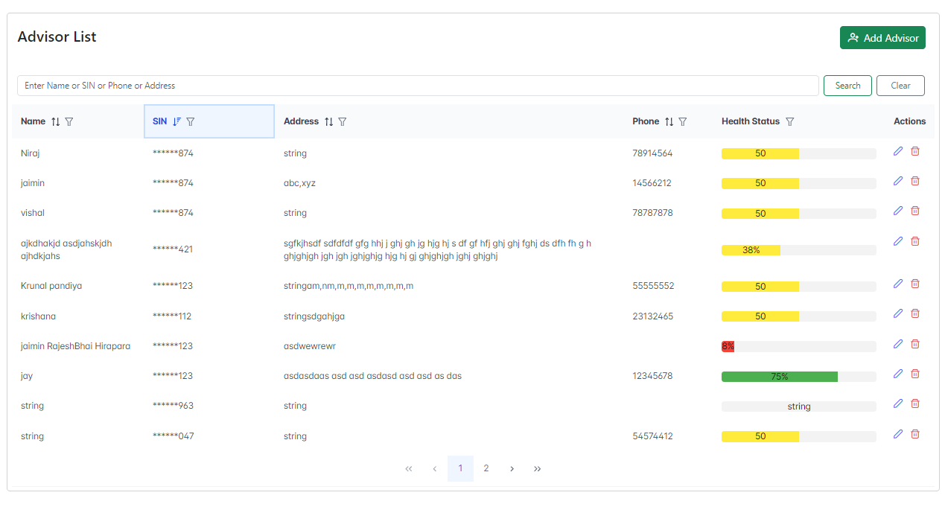

1. **Sort with Address (Asc and Desc):**

**🡪 Sorting Address Ascending**

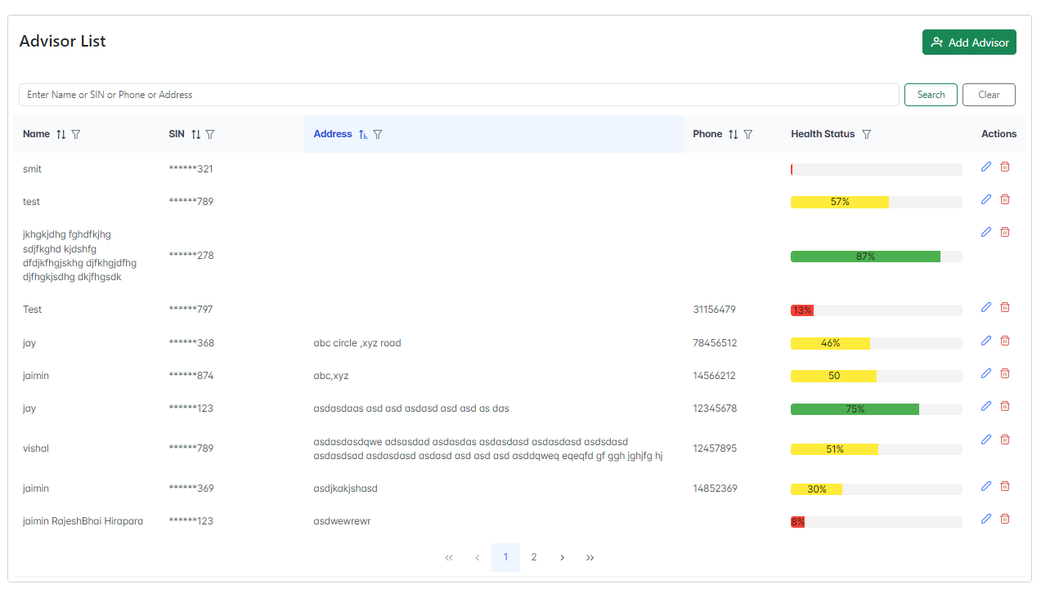

* **Sorting Address descending**

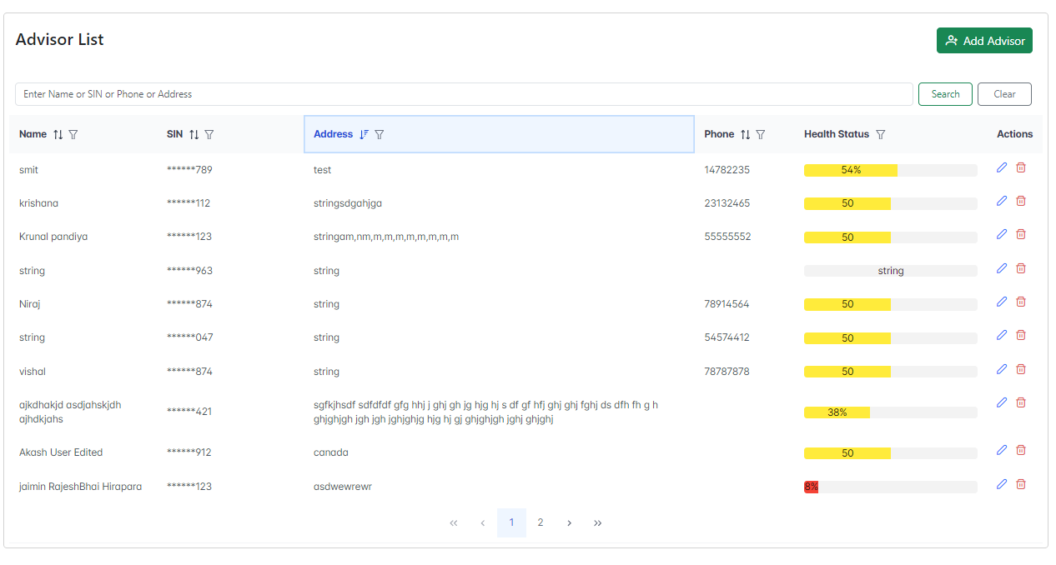

1. **Sort with Phone (Asc and Desc):**

**🡪 Sorting Phone Ascending**

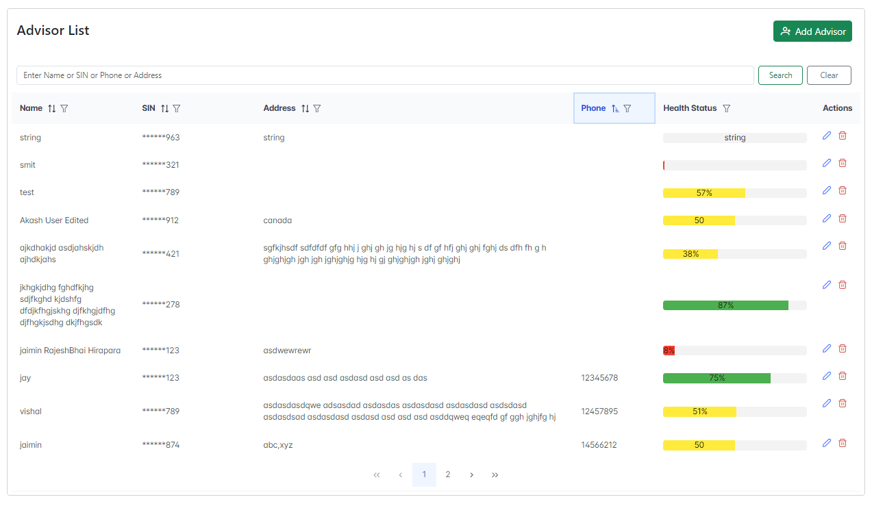

* **Sorting phone Ascending**

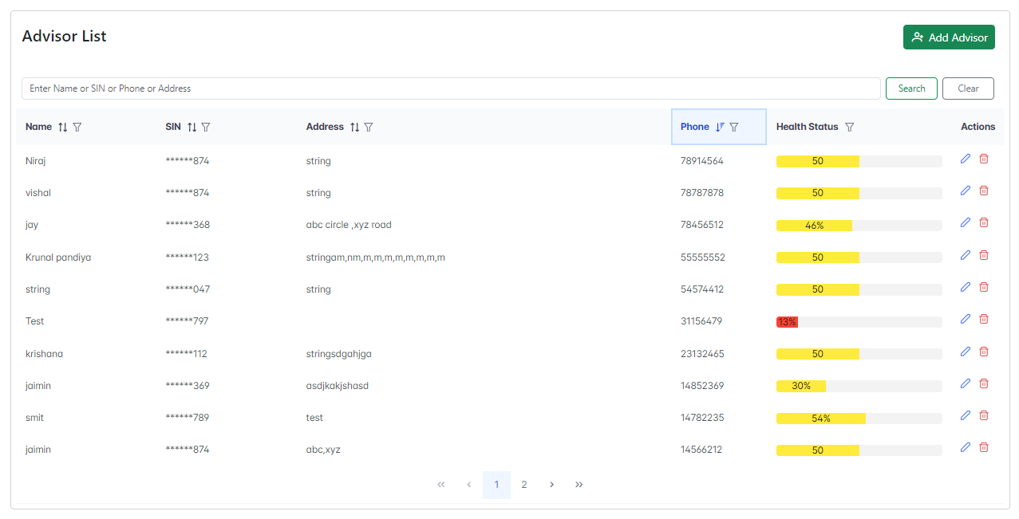

* **Filters:**

**🡪 we applied the filter on Name , SIN, Address, Phone, HealthStatus fields.**

* **We filter according Starts with , contains,not contains,ends with, equals, not equals.**

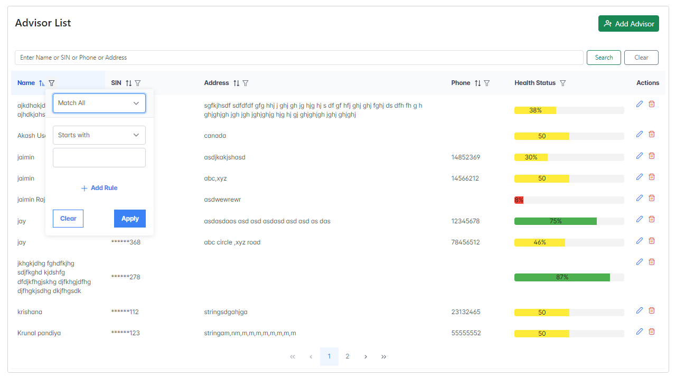 

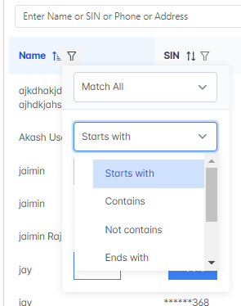

**Test case 1:**

* **We apply the filter on Name with the Start with the jaimin.**

**Input:**

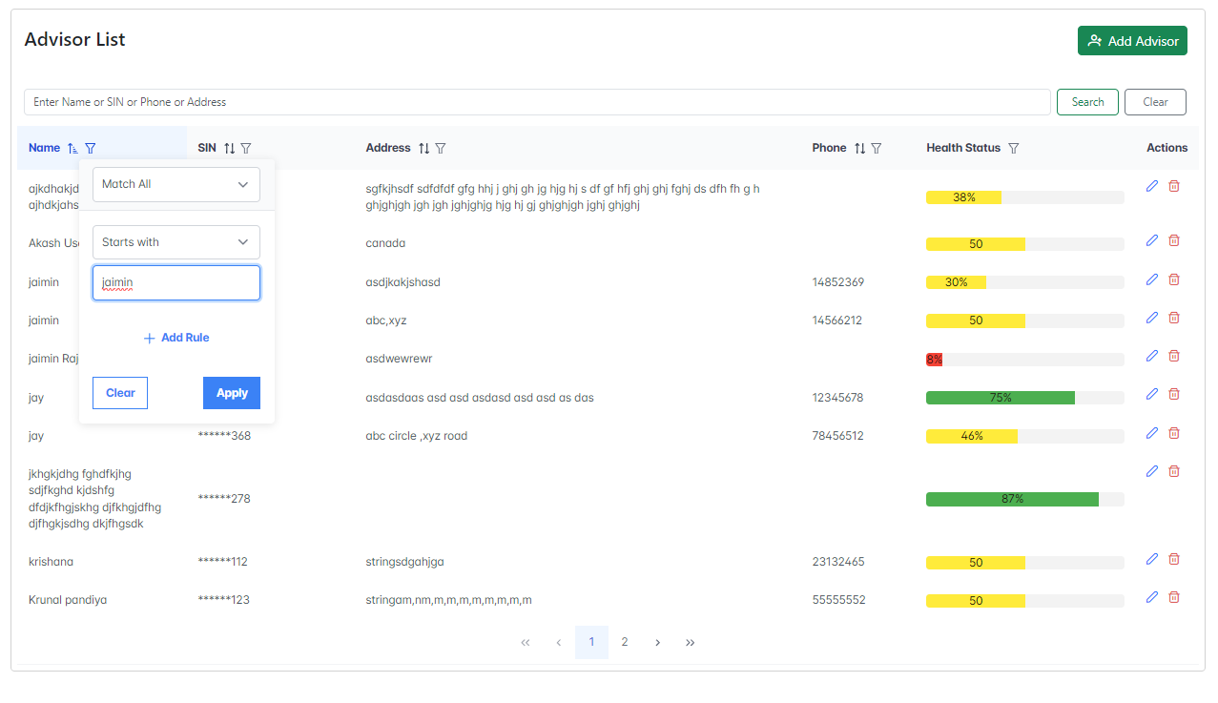

**Output:**

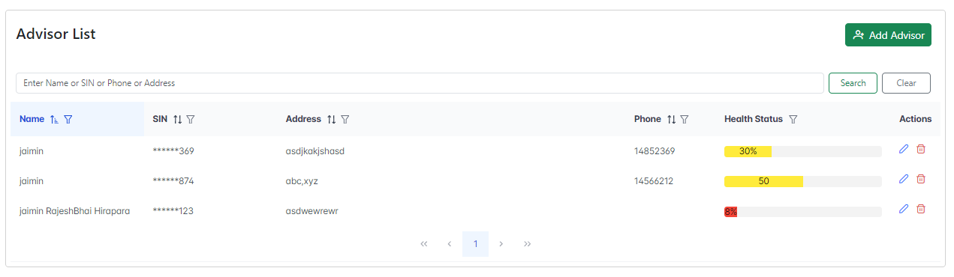

**Test Case 2:**

* **We can apply contains on the Name field with the field as ‘j’.**

**Input:**

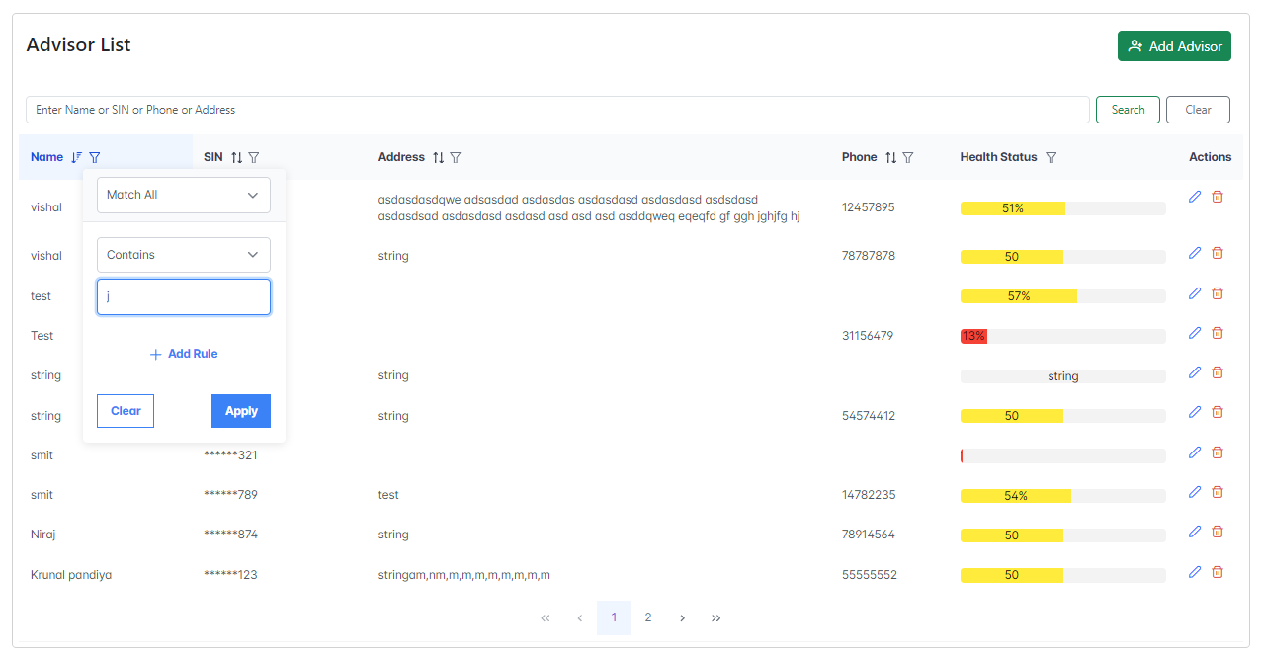

**Output:**

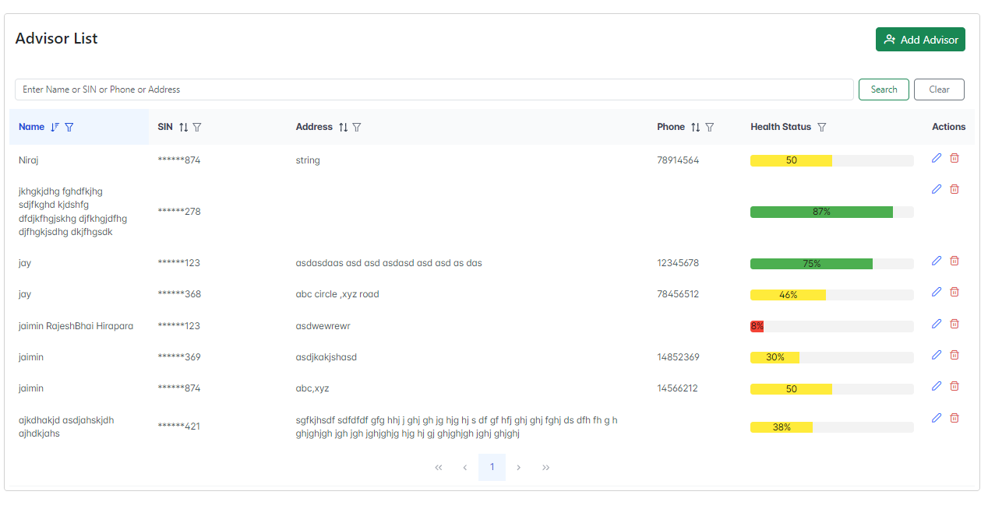

**Test Case 3:**

* **We can apply not contained in the Name field with the field as ‘test’.**

**Input:**

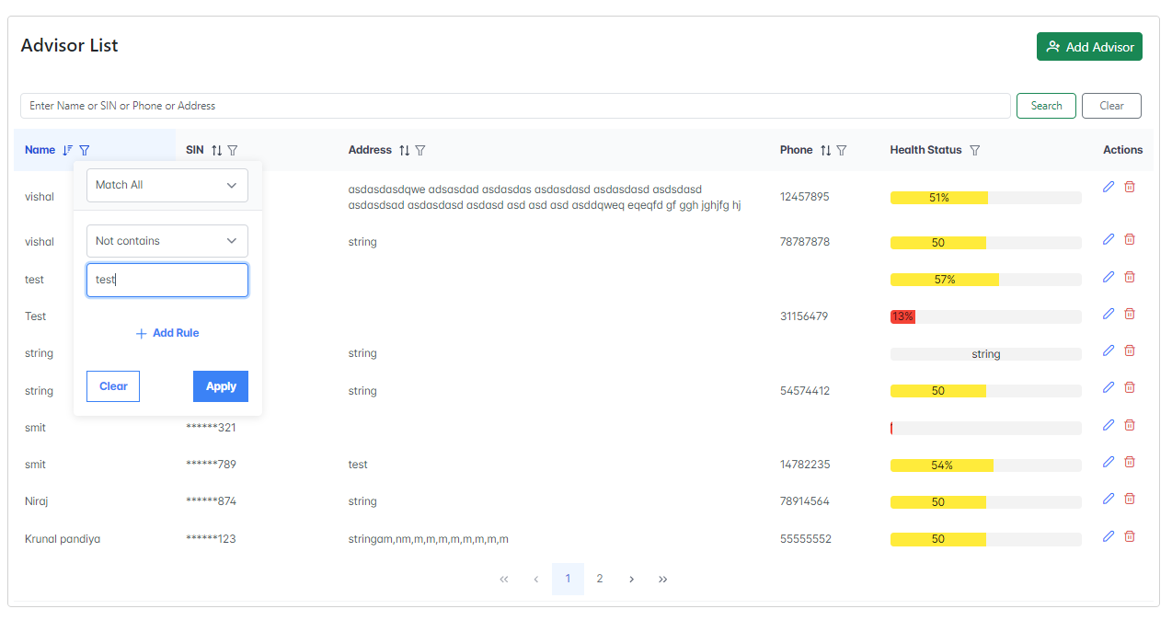

**Output:**

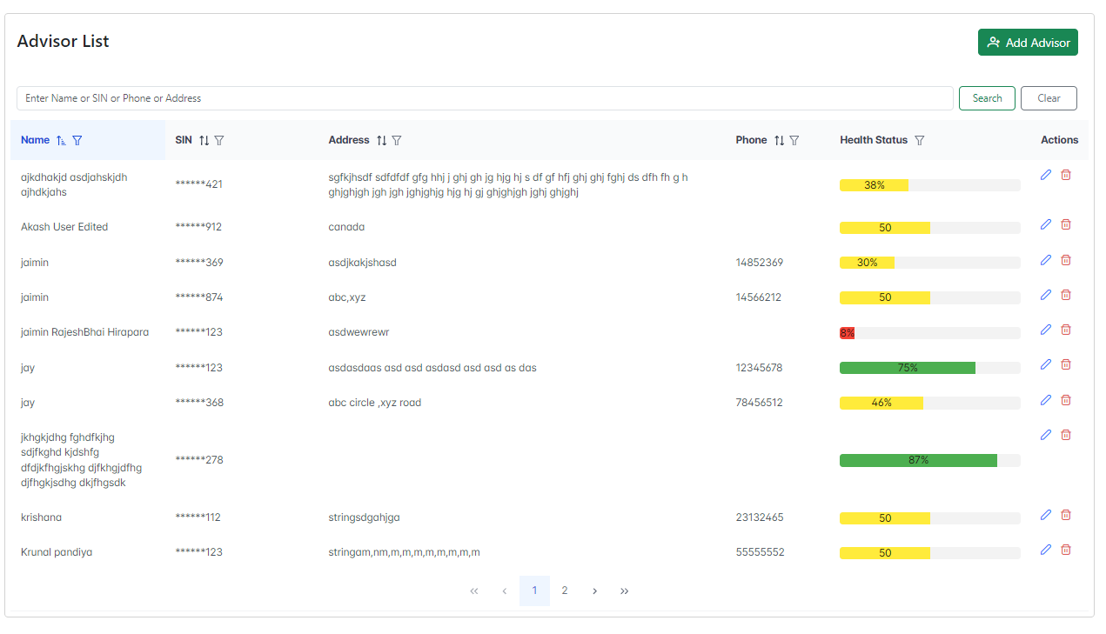

**Test Case 4:**

**🡪 We can apply Ends with on the Name filed with the filed as ‘test’.**

**Input:**

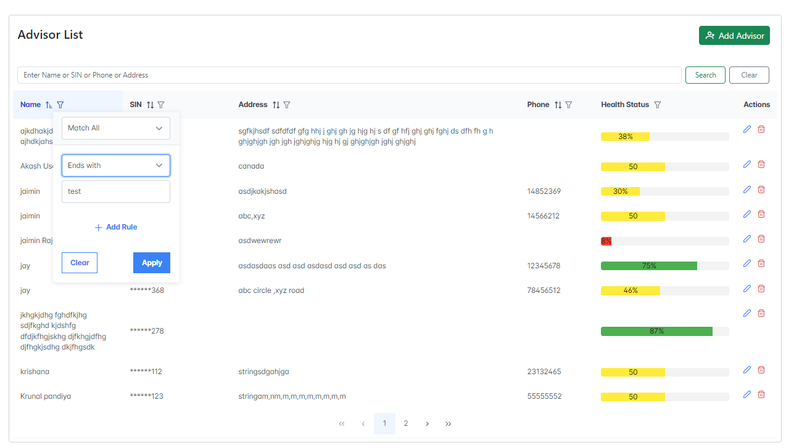

**Output:**

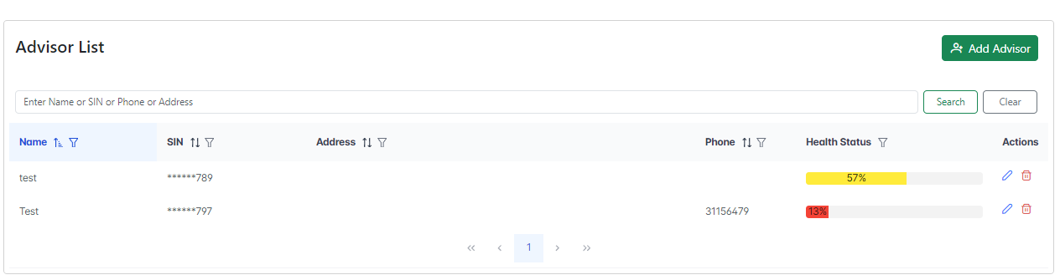

**Test Case 5:**

* **We can apply equals on the Name field with the field as ‘test’.**

**Input:**

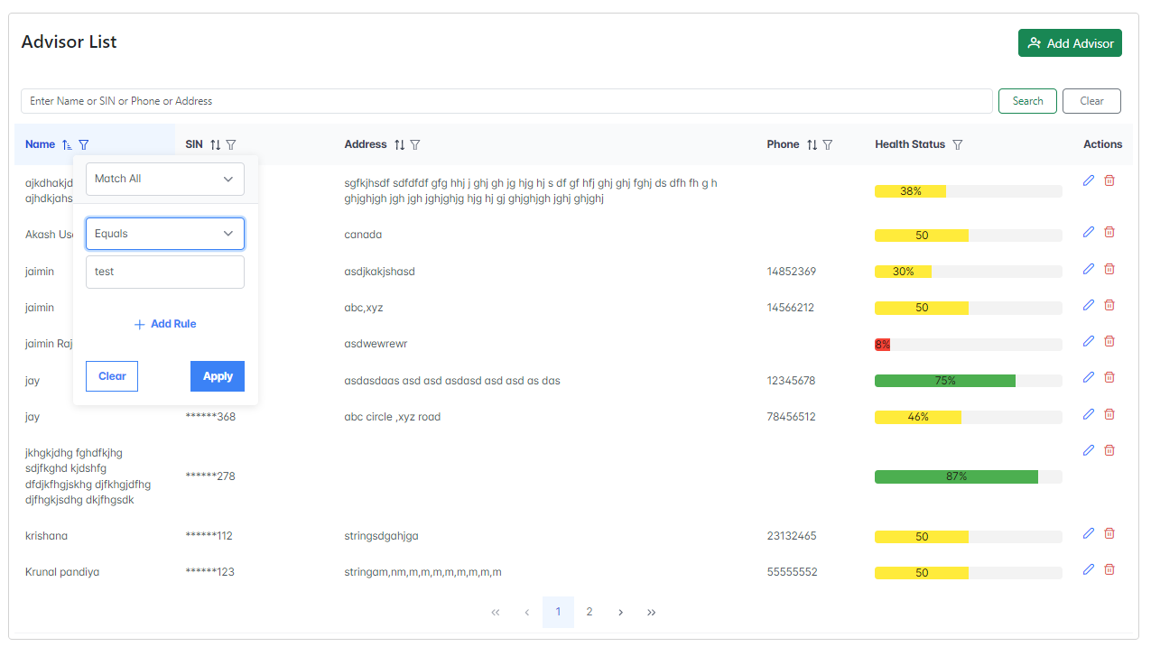

**Output:**

